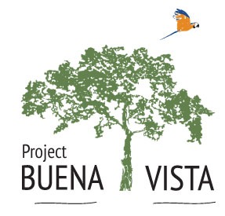
Volunteer Application
Project Buena Vista is implementing an application process in order to ensure that we maintain the highest level of professionalism on our medical outreach trips to the Peruvian Amazon. The application is to be filled out by both medical professionals and clinic support staff. The application is to be submitted by email to projectbuenavista@gmail.com or via mail to
Project Buena Vista
15 Otsdawa Ave
Otego, NY 13825 USA
Please note that there are 3 parts to the application
Part 1: General information
Name: Email:
Address: Phone:
Profession/Specialty:
License number: State: Country:
Circle One: Clinical support staff Licensed Acupuncturist
Licensed Massage therapist Other
Part 2: Essay
Provide us with a 1 page or less essay describing why you feel you are a good candidate for a trip like this. Include your philosophy of medical care and why you think medical outreach is beneficial to the communities we serve. If you are not a medical provider, explain what role you expect to play on the medical team as well as why you would like to volunteer for this project.

Part 3: References
Provide contact information for 2 professional references including name, phone number and email.

Thank you for your application. Please give us 2 weeks to process the application. Each team consists of 1-3 medical professionals and 1-2 support staff. Our next trip is scheduled to meet in Cusco Peru April 10 and depart from Cusco April 21, 2015.

